Project-CSE326

Introduction:-

Group-6:-

Task:-Fitness Club

Section:-K22GT

Group members:-

Ansh Arora(17) Anurak Rana(15)

Work distribution:-

Home.html(50%,50%)

Gallery.html(100%Anurak)

Aboutus.html(100%Anurak)

Trainings(50%,50%)

Time_table.html(100%Ansh)

Nutrition.html(100%Ansh)

Github link:-

[AnshAror-a (github.com)](https://github.com/AnshAror-a)

Objective of the project:-

Making an interactive website for a gym.

The screenshot below was our task to make. The only change we have done is add an video instead of an image. The video seems to autoplay only when muted.

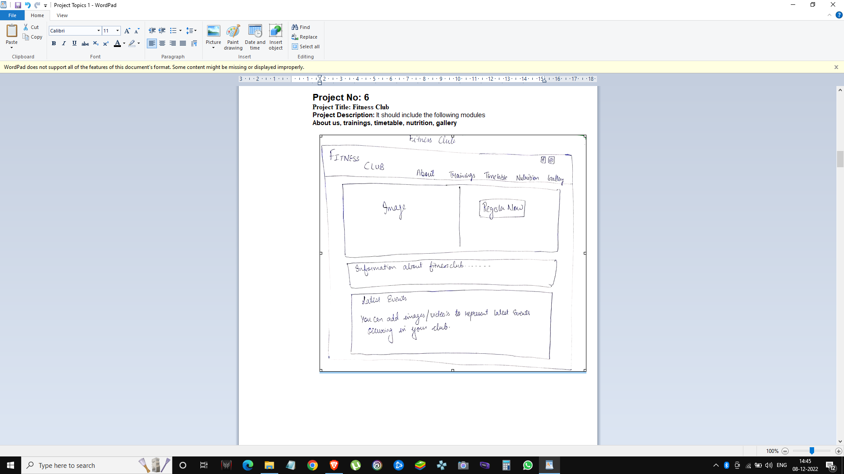

Description of the project:-

Fitness Club website using html, css and javascript.We have used

transition on various tags and classes to have a responsive website.

Scope of the project:-

The goal was to successfully improve our html,css and javascript via this project.The project can be used by modern day gyms to advertise themselves. The stylesheets were split in 3 different files in order to avoid any sort of clash between files.

System Description:-

We have used @fontface to apply font to text inside the document(reference:-w3schools),i frames to with fadeout using javascript(reference:-w3schools),linked it to external stylesheet,included a icon for the website, used header, divs for different images and texts,used forms(referemce:-w3schools).

Screenshots:-

Home page:-

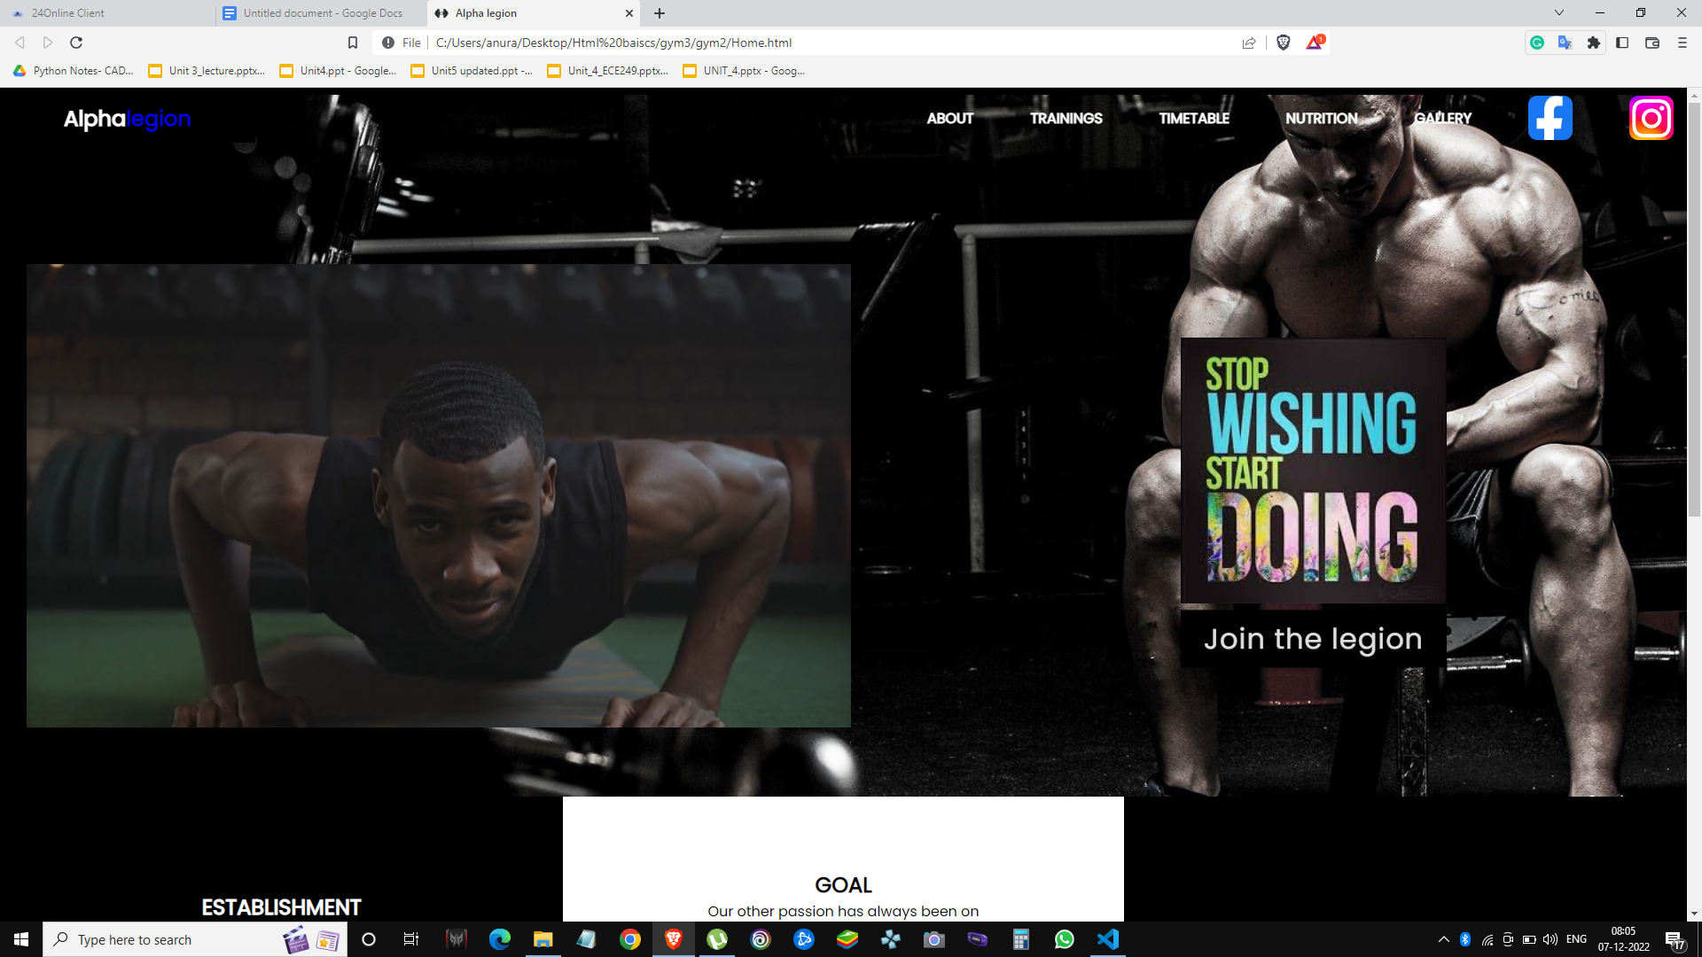

The links and icons of facebook and instagram are inside the header.The image has the margin top of 10% but the header stays above due to the hr tag directly below it.

The links will glow red when the mouse hovers over them and still be red after clickin on it the social media links will lead you to the social medias page(future work).

This has the form on the right and and video which is muted looped and autoplaying on the left including an image on the top of the div (join the legion).

The font used is in @fontface(reference:-w3schools).

The alpha legion are present inside the css file style.css.

HTML for the join the legion div:-

<div class="banner">

<div class="center">

<video width="960px" height="540px" autoplay muted loop style="padding-left: 30px; margin-top: 10%;">

<source src="sehaj.mp4" type="video/mp4">

</video></div>

<div class="intro">

<img src="before.jpg" height="300px" width="300 px">

<form>

<input id="input-1" type="text" placeholder="Your name" required />

<label for="input-1">

<span class="label-text">Full Name</span>

<div class="signup-button-trigger">Sign Up</div>

</label>

<input id="input-2" type="text" placeholder="Username" required />

<label for="input-2">

<span class="label-text">Username</span>

</label>

<input id="input-3" type="email" placeholder="Email" required />

<label for="input-3">

<span class="label-text">Email</span>

</label>

<input id="input-4" type="password" placeholder="Password" required />

<label for="input-4">

<span class="label-text">Password</span>

</label>

<input id="input-5" type="password" placeholder="Confirm password" required />

<label for="input-5">

<span class="label-text">Confirm Password</span>

</label>

<button type="submit" style="background-color: white;color: black;">Create Your Account</button>

<div class="signup-button">Join the legion</div>

</form>

</div>

</div>

<div class="row ">

<div class="card " style="color: white;background:black; ">

<h2>Establishment</h2>

<p>cCONTENT</p>

CSS:-

.signup-button,

.signup-button-trigger {

top: 50%;

left: 30%;

transform: translate(0%, -100%);

width: 300px;

padding: .25rem 0;

line-height: 3.6rem;

text-align: center;

pointer-events: none;

cursor: pointer;

transition: opacity .4s .3s;

}

.signup-button-trigger {

opacity: 0;

pointer-events: auto;

}

Home page:-(2)

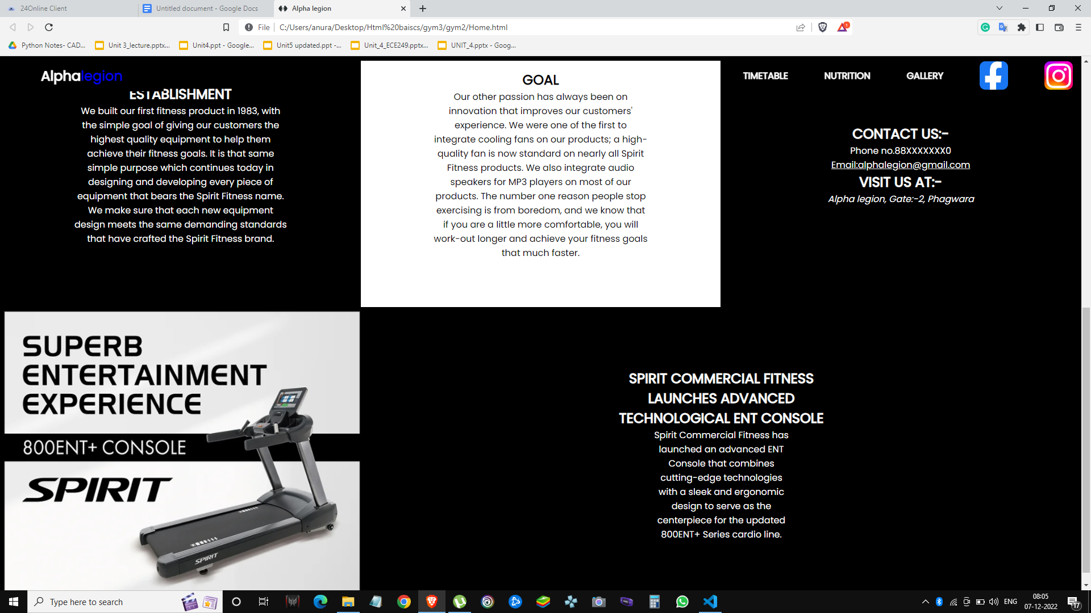

The gyms description in the center of the page as you can see the heading(h2) establishment,goal,contact us.All of them are divs with class row and card.The lower end of the webpage is iframes both iframes combined take up 99.9% of the width.

The content is switched among them after every 10 seconds.

This switch was possible due to the following function:-

function showSlides() {

let i;

let slides = document.getElementsByClassName("mySlides");

for (i = 0; i < slides.length; i++) {

slides[i].style.display = "none";

}

slideIndex++;

if (slideIndex > slides.length) {

slideIndex = 1

}

slides[slideIndex - 1].style.display = "block";

slides[slideIndex - 1].className += " active";

setTimeout(showSlides, 10000);}

About us page:-



This is the About us page the image has its background color as black and the about us with text below also has the background color as black, they are inside the section tag with has the attributes of box shadow.

CSS:-

section {

display: grid;

min-height: 70vh;

width: 75vw;

margin: 0 auto;

box-shadow: 0 4px 8px 0 grey, 0 6px 20px 0 grey;

border-radius: 12px

}

HTML:-

<div class="image"><img src="bt1.jpg"></div><div class="content"><h2>About Us</h2><p>TEXT</p>

<ul class="links">

<li><a href="Home.html">Home</a></li>

</ul></div>

Trainings page:-

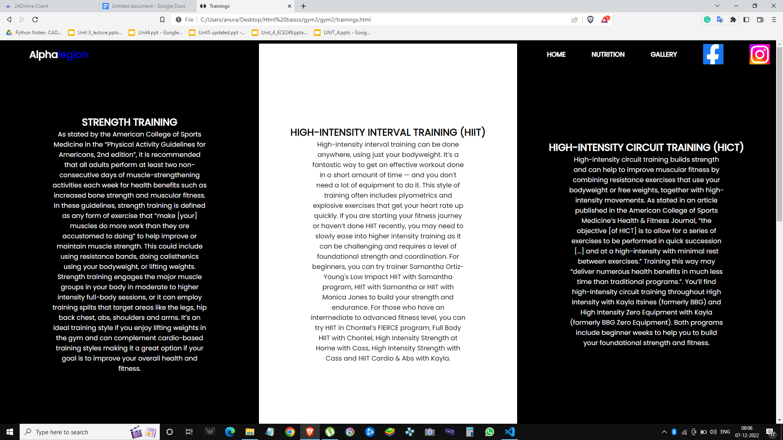

This page has 3 divs each of height 1000px and their class are row and cards/cards2 respaectively. Each heading of each card is a link.

<div class="row "><div class="card2 " style="color: white;background: black; "><h2><a href="#">Strength training</a></h2><p>TEXT </p></div>

CSS:-

.card {

width: 33.3%;

height: 500px;

display: flex;

justify-content: center;

flex-direction: column;align-items: center;

}

.card h2 {

text-align: center;

text-transform: uppercase;

}

.row {

display: flex;

justify-content: center;}

Time table page:-

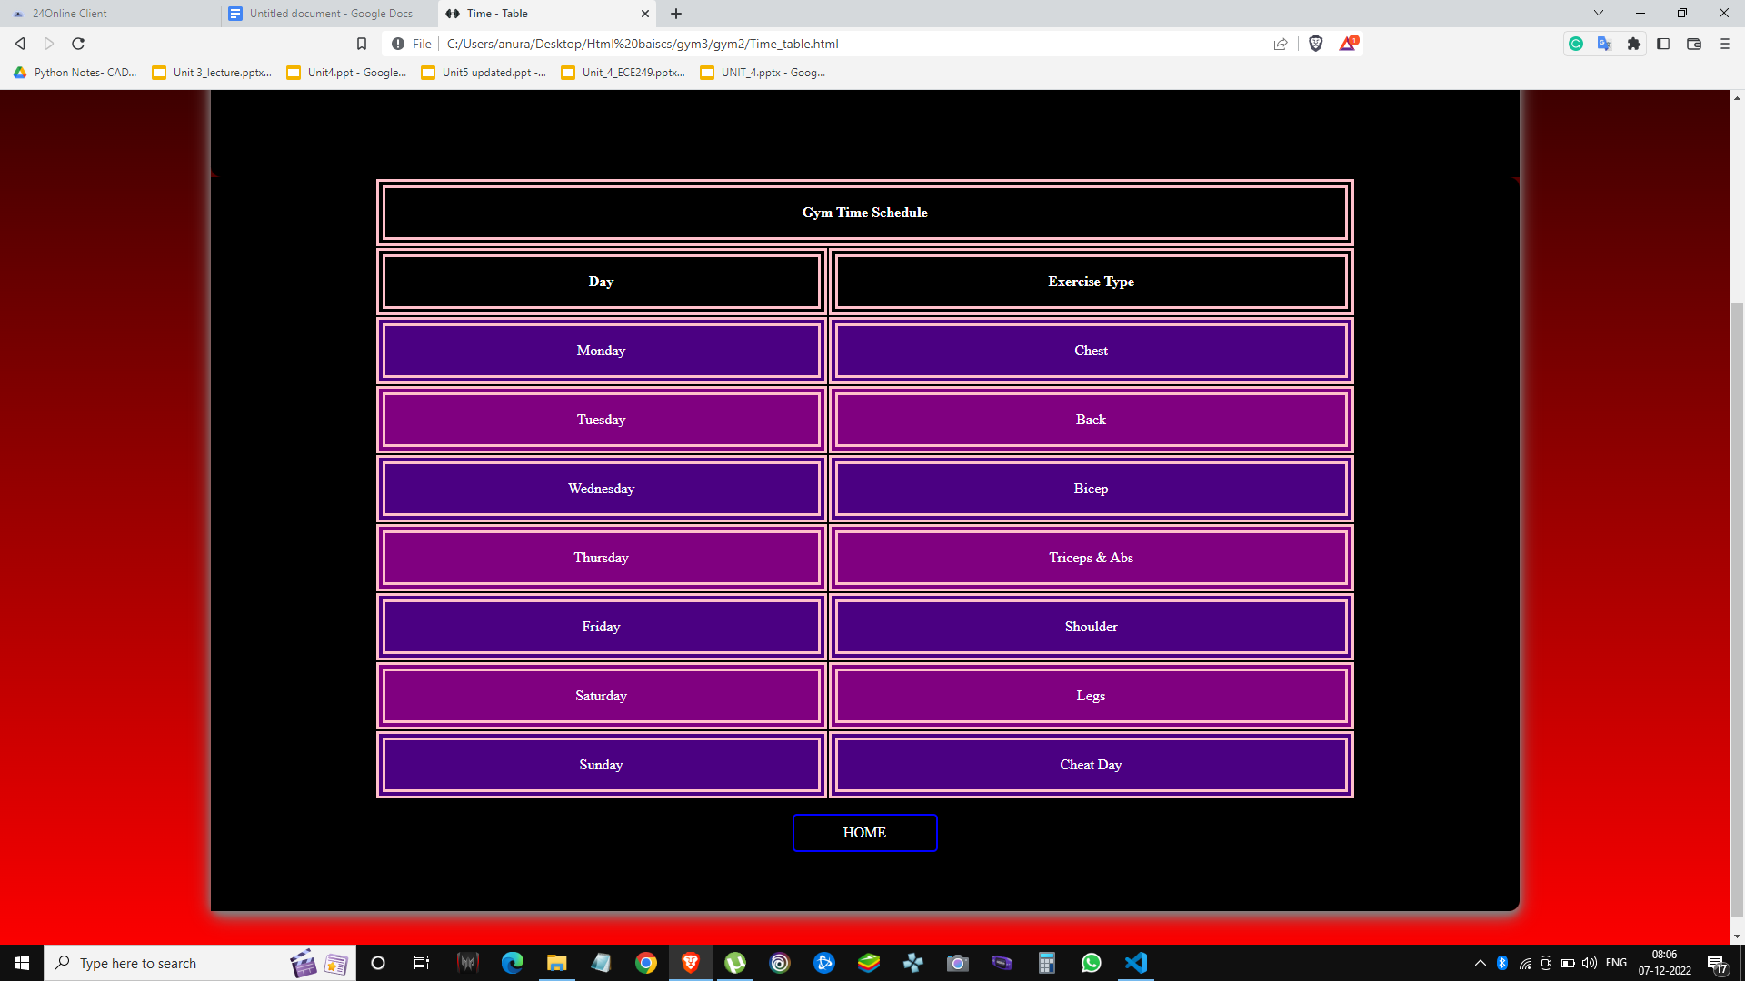

Using table inside the section similar to our our about us page we have created a time table for any gym enthusiast that maybe interested.

HTML:-

<div class="content"><table><tr><th colspan="2">Gym Time Schedule</th></tr><tr><th>Day</th>

<th>Exercise Type</th>

</tr>

<tr>

</table>

<ul class="links">

<li><a href="Home.html">Home</a></li>

</ul>

<ul class="icons">

<li><a href="https://www.instagram.com/"> <i class="fa fa-instagram"></i></a></li>

<li><a href="https://www.facebook.com/"> <i class="fa fa-facebook"></i></a> </li></ul>

</div>

CSS:-

td,

th {

border: 10px double pink;

padding: 18px;

}

table {

width: 75%;

text-align: center;

}

tr {

background-color: purple;

}

th {

color: white;

background-color: black;

}

#Sd {

border: 10px double cyan;

padding: 25px;

}

tr:hover {

background-color: #C850C0;

}

tr:nth-child(odd) {

background-color: indigo;

}

Nutritions page:-

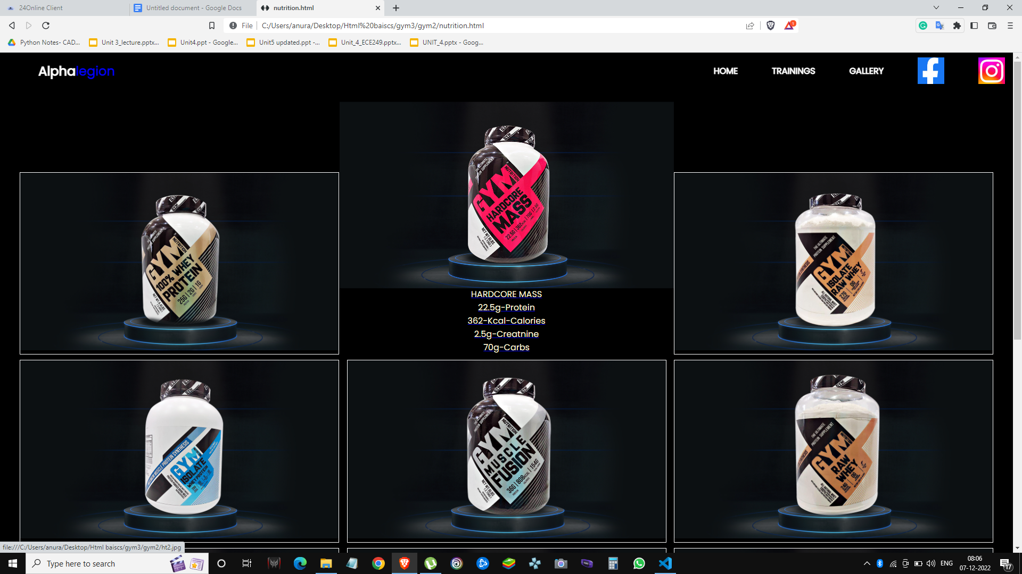

Using the following code with their functions we have successfully made an interactive page that tells you about the contents of the items you have hovered over

(onmouseover="over()" onmouseout="out()”)

JAVASCRIPT:-

function over1() {

document.getElementById('d1').innerHTML = "100% WHEY PROTEIN" + '<br>' + "25g-Protein" + '<br>' + "120-Calories" + '<br>' + "1g-Sugar" + '<br>' + "2g-Carbs";

}

function out1() {

document.getElementById('d1').innerHTML = " ";

}

Gallery page:-

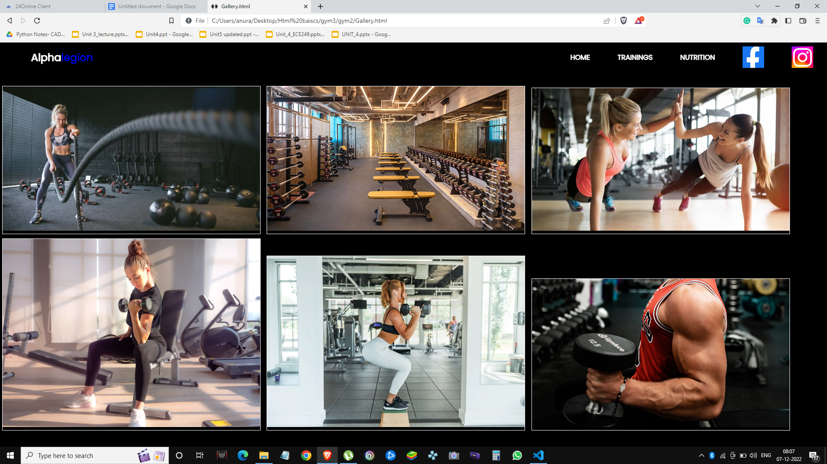

The gallery was made by using the img:hover {transform: scale(1.2);}, the images become 1.2X their size when they are hovered over.All of them are are divs inside the main div, the main div has the padding top of 5%.

CSS:-

div.gallery {

margin: 5px;

border: 1px solid white;

display: inline-block;

width: 600px;

}

div.gallery:hover {

border: 1px solid black;

}

div.gallery img {

width: 100%;

height: auto;

}

div.desc {

padding: 15px;

text-align: center;

}

img:hover {

transform: scale(1.2);

}

The updates page:-

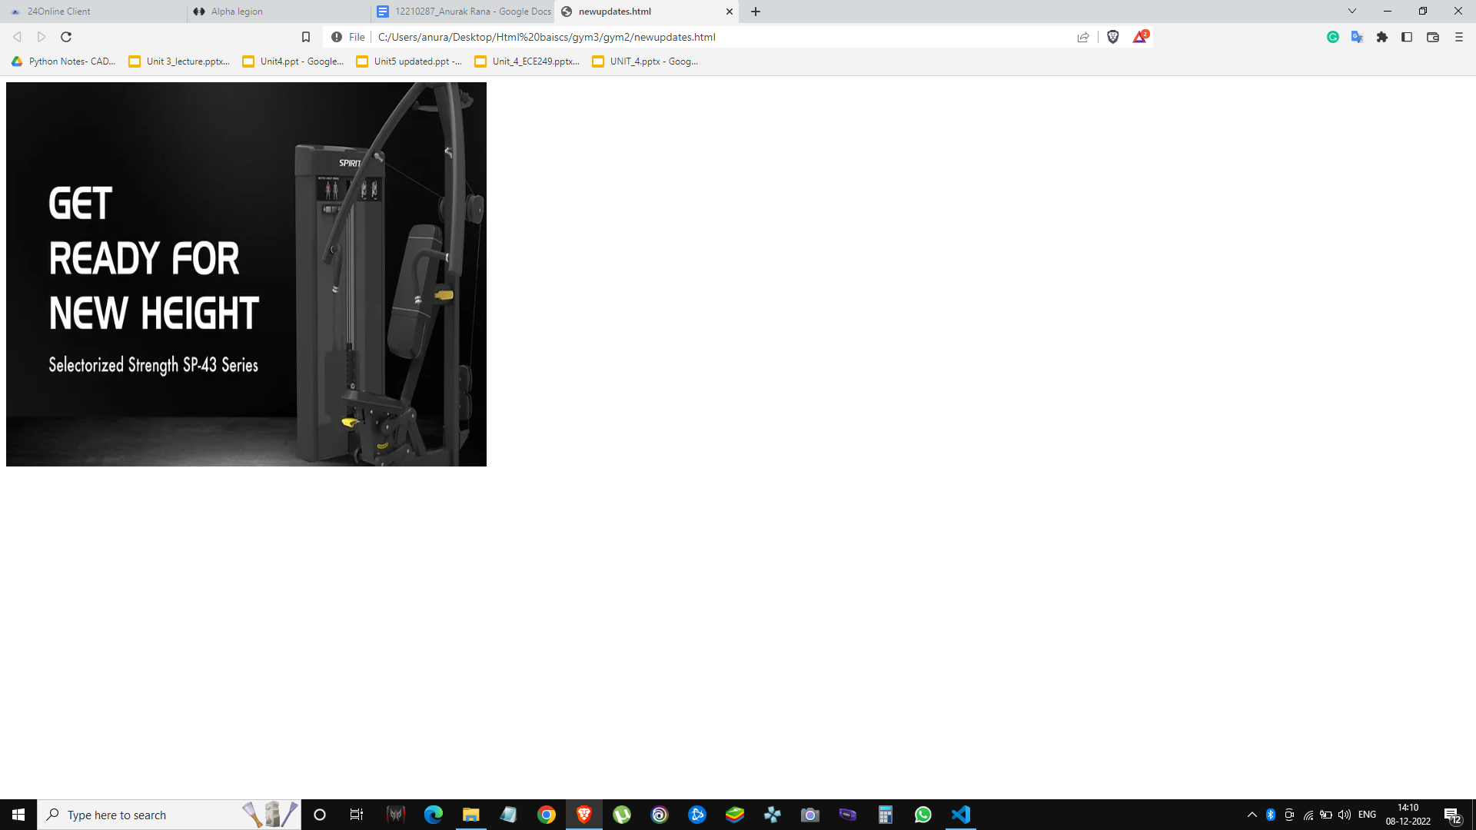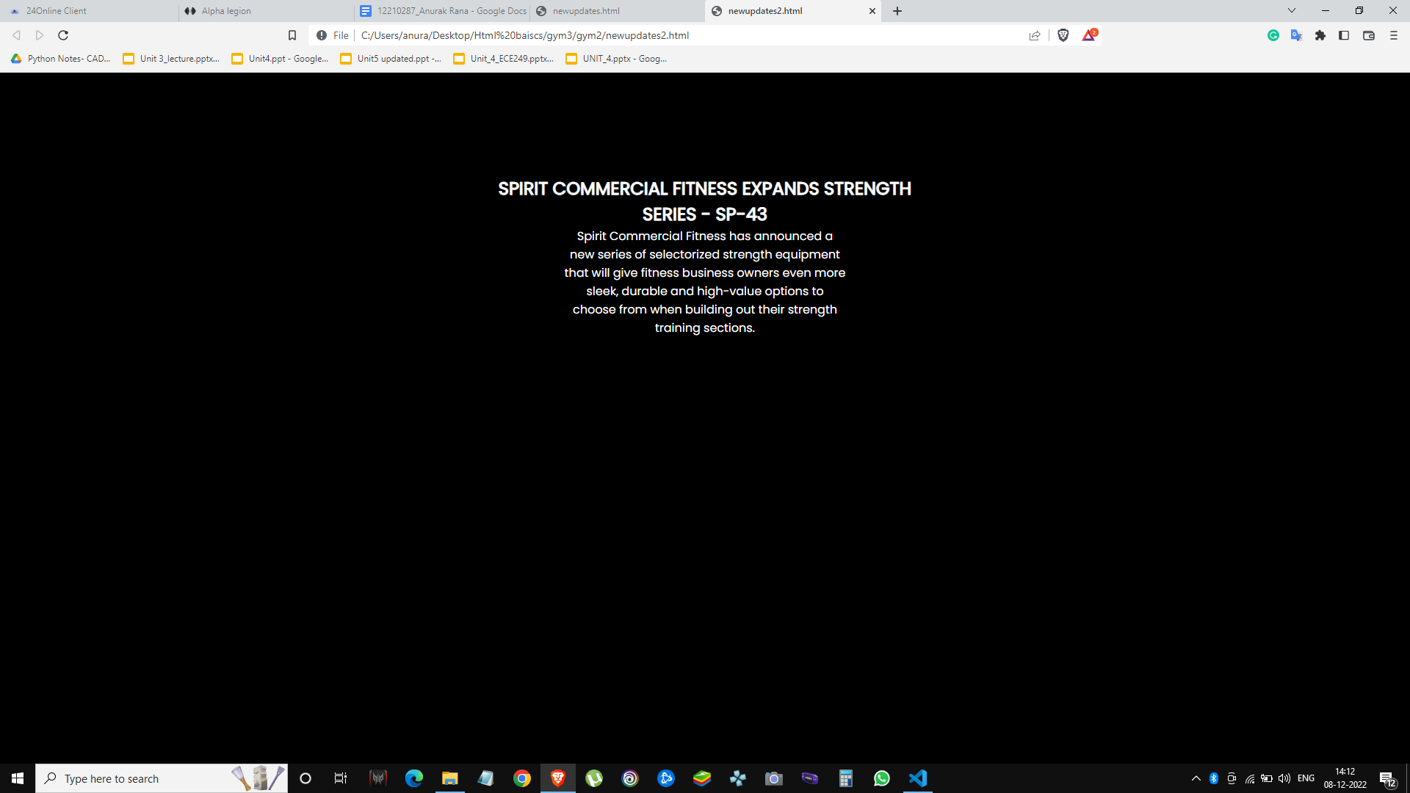

CSS:-

div {

display: inline-block;

}

* {

box-sizing: auto;

}

.mySlides {

display: none;

}

.fade {

transition: background-color 0.6s ease;

animation-name: fade;

animation-duration: 1.5s;

}

@keyframes fade {

from {

opacity: .4

}

to {

opacity: 1

}

}

@media only screen and (max-width: auto) {

.text {

font-size: 11px

}

}

HTML:-

<div class="slideshow-container">

<div class="mySlides fade">

<img src="at1.jpg" style="height:500px; width:625px">

</div>

<div class="mySlides fade">

<img src="at2.jpg" style="height:500px; width:625px">

</div>

<div class="mySlides fade">

<img src="at3.jpg" style="height:500px; width:625px">

</div>

<div class="mySlides fade">

<img src="at5.jpg" style="height:500px; width:625px">

</div>

<div class="mySlides fade">

<img src="at6.jpg" style="height:500px; width:625px">

</div>

</div>

JAVASCRIPT:-

let slideIndex = 0;

showSlides();

function showSlides() {

let i;

let slides = document.getElementsByClassName("mySlides");

for (i = 0; i < slides.length; i++) {

slides[i].style.display = "none";

}

slideIndex++;

if (slideIndex > slides.length) {

slideIndex = 1

}

slides[slideIndex - 1].style.display = "block";

slides[slideIndex - 1].className += " active";

setTimeout(showSlides, 10000);##The time the images switch can be changed through here

}

Future work:-

The form will be further improved by using css and having th buttons become more interactive, a validator will also be used for pass and confirm password.The forms submit button is also needed to be appeared while pressing enter. The website needs to be optimized according to the height of width of different devices. Footers need to be added.A social media page needs to be made for the website.Each and every image will be hyperlinked

References:-

W3schools

geeksforgeeks